STATE OF ALABAMA

[agency name]


[agency logo, if applicable]

CONTINUITY OF OPERATIONS PLAN
Draft Date: mm/dd/yyyy
Issue Date: mm/dd/yyyy

[insert WS 1 here]

Table of Contents

I. RECORD OF CHANGES 1
II. PREFACE 2
III. INTRODUCTION 4
IV. COOP ELEMENTS 5
A. PROGRAM PLANS AND PROCEDURES 5
1. CONTINUITY PLANNING ROLES AND RESPONSIBILITIES 5
a) Senior Leadership 5
b) Continuity Coordinator 5
c) Continuity Planning Team 5
d) Individual Employees 6
e) Continuity Planning Team Organization 6
2. CONTINUITY POLICY 6
3. GOALS 6
4. CONCEPT OF OPERATIONS 6
a) Applies to All Hazards EXCEPT Pandemic Influenza 6
b) Criteria for Suspending All Functions and Services 7
c) Applies to Pandemic Influenza 7
d) Criteria for Suspending All Functions and Services 8
5. GO-KITS 8
6. Incident Command System 8
B. HAZARD VULNERABILITY ANALYSIS 9
1. Natural Hazards 10
2. Human Initiated Hazards 10
3. Technological Hazards 10
C. BUDGETING AND ACQUISITION OF RESOURCES 11
1. COOP Budget 11
2. Key Resources and Acquisition 11
D. ESSENTIAL FUNCTIONS and TELEWORK PLAN 11
1. Essential Functions 11
2. Telework Assignments 11
E. ORDER OF SUCCESSION 12
F. DELEGATION OF AUTHORITY 13
G. CONTINUITY FACILITIES 13
H. CONTINUITY COMMUNICATIONS 14
1. Continuity Communications--Internal 14
2. Continuity Communications--External 15
3. 15
4. VITAL RECORDS MANAGEMENT 16
I. HUMAN CAPITAL 17
1. Evacuations and Rally Points 17
2. Pandemic Influenza Employee Risk Assessment Instrument 18
3. Organizational Census with Employee Pandemic Influenza Risk Assessment 19
4. Monitoring Employee Availability and Absences 20
J. TEST, TRAINING, AND EXERCISE (TT&E) PROGRAM 20
1. ALL hAZARDS tRAINING AND EXERCISES 20
2. Pandemic Influenza Training and Exercises 20
K. DEVOLUTION OF CONTROL AND DIRECTION 20
L. RECONSTITUTION OPERATIONS 20
V. CONTINUITY PLAN OPERATIONAL PHASES AND IMPLEMENTATION 21
A. Alert, Standby, Activate Phases 21
B. Pandemic Influenza 21
1. Operational Phases 22
APPENDIX A: Directive from the Governor of the State of Alabama 24
APPENDIX B: State of alabama and County hazard vulnerability analyses 25
2. state of alabama hva 25
3. county hvaS 26
APPENDIX C: PANDEMIC INFLUENZA PLANNING ASSUMPTIONS 27
APPENDIX D: PANDEMIC INFLUENZA telework plan 29
APPENDIX E: DOCUMENTATION OF COMPLIANCE WITH APPENDIX A OF THE CDC STATE PANFLU OPERATIONS PLAN 30
APPENDIX F: INCIDENT COMMAND SYSTEM 34
APPENDIX G: TOOL FOR MONITORING EMPLOYEE AVAILABILTY AND ABSENCES 36
APPENDIX h: ACRONYMS 37

RECORD OF CHANGES

Date | Page Number | Brief Description of Change Made | Person(s) Making Change

PREFACE

Regardless of whether you manage a for-profit, not-for-profit, or public sector organization, planning is important. Planning at its best is anticipating and making provisions for the future. At the very least planning is about avoiding surprises that can disrupt and possibly destroy your organization. Surprises may come frequently but cause only minor inconveniences such as power outages during summer thunderstorms. Alternatively, surprises may be infrequent but represent major disasters in the form of hurricanes, tornados, or even terrorists’ attacks. If organizations are not properly prepared even power outages can cause major disruptions. Hospitals must switch to emergency generators, elective surgeries might be postponed, and people have episodes of terror as elevators stop working and traffic lights leave us in hopeless logjams.

Many organizations correctly devote time and other resources to the development of comprehensive strategic plans. Unfortunately, many of these same organizations do not devote equal attention to ensuring the continuity of operations during times when their normal operations are disrupted. This possibility is why organizations need continuity of operations plans or (COOPs). A well conceived COOP encourages individuals to think about the resources needed to ensure the continuity of operations under the most inconvenient or disastrous situations. The authors are aware of more than one highly sophisticated business organizations in the Gulf Coast region that was not prepared for the most basic disruptions caused by Hurricanes Rita and Katrina. One did not even have its payroll system backed up and in a location away from the primary site of its business operations. Soon after operations were restored people in the accounting department were calling employees asking if they had their pay statements from the previous period so records could be reconstructed and operations resumed.

Continuity of Operations Plans are designed to engage informed people in organizations in thinking about the most basic aspects of their organizations operations – What are the essential functions that our business, hospital, or government agency must perform if we are to operate as demanded by our stockholders, patients, or the citizens at large? More pragmatically, what records and files are essential for conducting our business, who is in charge if one or more key individuals are not able to perform their duties, and where and how do we operate if our building is destroyed or deemed inoperable?

Continuity of operations planning is inherently a job that must be done by “insiders.” – people who work and make their living every day in an organization, know what the organization’s essential functions are as well what records are absolutely necessary to carry on the work, and what leadership succession plan is most likely to succeed. However, we have found that outsiders can assist in facilitating the thinking of insiders. Or, as we like to say helping smart people translate what they already know to formal documents. To this end, we have developed a method we call fCOOP or Focused Continuity of Operations Planning. fCOOP is a process not an end product. It is an efficient and practical process that enables informed individuals to come together in a structured group environment using a series of guides and templates. Using these tools these people can make remarkable progress toward the development of a COOP. Our experience in a number of business firms, health care organizations, universities, and government agencies is that the first round of group interaction and decision making can generate as much as 80 percent of the information needed to complete the continuity of operations plan. The remaining 20 percent can be finalized with one or two “virtual meetings” of the group and the facilitators. These virtual meetings are usually dedicated to clarifying and refining the information obtained in the initial fCOOP session.

Leaders are responsible for ensuring that their organizations can function even under the most disruptive conditions. Continuity of operations planning is an essential tool for leaders in these times of “whitewater” change. The challenges facing today’s organizational leaders are formidable but not overwhelming. Continuity of operations planning is a leader’s best chance of dealing with future threats and surprises. The material in this manual is directed toward creating all hazards continuity of operations plans. It is important to have COOPs that can address the disruption regardless of its form – earthquake, bioterrorism, droughts, and floods. We recognize, however, that certain disasters present unique challenges. For this reason we include discussions of a particular type of disaster – pandemic influenza. Pandemic influenza is a disaster of a very special kind. It defies most of the conventional planning wisdom that applies to other hazards. Whereas hurricanes, tornados, floods and even terrorists attacks affect many people and some quite severely in a limited geographical area, pandemic influenza is particularly frightening. An influenza pandemic “affects all of us” in time and is not limited to a particular place. Whereas the good people of Indiana or Washington may be quite willing and able to assist victims of a flood in Arkansas, a tornado in Oklahoma, or hurricane in Louisiana no such help can be expected or anticipated in the case of pandemic influenza. Such an outbreak will potentially affect everyone, perhaps around the globe and may do so for months, maybe a year, or longer. In view of this we have included discussions on maintaining continuity of operations in both an all hazards environment and in the event of pandemic influenza.

We hope this template for continuity of operations planning will be useful to you and to your organization. The COOP Template, COOP Work Sheets, the fCOOP process, and the fCOOP PowerPoint presentation were created by Andrew C. Rucks, Ph.D.; W. Jack Duncan, Ph.D., and Peter M. Ginter, Ph.D. of the School of Public Health, the University of Alabama at Birmingham under a contract with the Alabama Department of Public Health. The authors greatly acknowledge the subject matter expertise, editing, and encouragement of: Cindy Lesinger, Alabama Department of Public Health; Stanley Bachelor, Cherie Cornelius, and Patrick Tritz of the Alabama Emergency Management Agency.

Andrew C. Rucks
W. Jack Duncan
Peter M. Ginter

INTRODUCTION

This Continuity of Operations Plan (COOP) has been prepared to conform to the requirements of the memorandum issued by Governor Bob Riley, April 10, 2009 (memorandum in Appendix A) directing all government entities to prepare a COOP to respond to “pandemic influenza and all-hazard emergencies.” The stimulus for the Governor’s directive was three federal references: (1) Homeland Security Presidential Directive 20/HSPD-20, May 9, 2007 (http://www.dhs.gov/xabout/law/ge_1219245380392.shtm); (2) National Preparedness Guidelines (NPG), September 2007 (http://www.dhs.gov.xlibrary/assets/National_Preparedness_Guidelines.pdf); and (3) National Response Framework, January 2008 (http://www.fema.gov/pdf/emergency/nrf/nrf-core.pdf).

The preparation of the following COOP adheres to the directions found in Continuity Guidance Circular 1 (CGC 1) for Non-Federal Entities, January 21, 2009 (http://www.fema.gov/pdf/about/org/nep/coop/continuity_guidance_circular.pdf). This COOP applies to all-hazard emergencies; however, it recognizes that pandemic influenza presents a set of circumstances that differ from other emergencies in that pandemic influenza will not limit its reach to this agency or part of this agency, but rather will affect all state entities (the planning assumptions associated with pandemic influenza are in Appendix C). Thus, each element of the COOP contains one or two sections. If one section it will be labeled by the heading “Applies to All Hazards AND Pandemic Influenza, and if two sections it will be labeled by the headings “Applies to All Hazards EXCEPT Pandemic Influenza” and “Applies to Pandemic Influenza.”

The continuity implementation process for [name of state entity] follows four phases—readiness and preparedness, activation and relocation, continuity of operations, and reconstitution. These four phases are linked as shown in the following model.

Figure 1. Continuity Implementation Process Model

COOP ELEMENTS

PROGRAM PLANS AND PROCEDURES

CONTINUITY PLANNING ROLES AND RESPONSIBILITIES

Senior Leadership

Senior leadership is directly responsible for ensuring that continuity plans and programs are developed, coordinated, exercised, and capable of being implemented when required. These responsibilities include:

- Designating a Continuity Coordinator.
- Approving all required continuity plans and programs.
- Notifying appropriate offices and organizations upon execution of continuity plans.
- Supporting the work of the Continuity Manager and Continuity Coordinator, including providing the necessary budgetary and other resources to support the continuity program, as required.

Continuity Coordinator

The Continuity Coordinator will coordinate the overall activities of the Continuity Planning Team. The responsibilities of the Continuity Coordinator include:

- Coordinating continuity planning activities with policies, plans, and incentives related to critical infrastructure protection.
- Leading the creation and coordination of the continuity planning process.
- Directing and participating in periodic cross-jurisdictional continuity exercises.
- Coordinating the input of the organization and ensuring those inputs reflect, support, and sustain the continuation of essential functions.
- Developing and maintaining the continuity plan.
- Developing and administrating a continuity program budget and submitting funding requests to Senior Leadership.
- Preparing an annual report summarizing the continuity planning activities of the organization.
- Serving as an advocate for the continuity plan and program.

Continuity Planning Team

The Continuity Planning Team coordinates continuity planning and duties for the entire organization. These duties include:

- Overall continuity coordination for the organization.
- Guiding and supporting the development of the organization’s continuity plan.
- Coordinating continuity exercises, documenting of post-exercise lessons learned, and conducting periodic evaluations of organizational continuity capabilities.
- Understanding the role that adjacent jurisdictions and organizations might be expected to play in certain types of emergency conditions and what support those adjacent organizations might provide.
- Understanding the limits of other jurisdictions continuity resources and support capabilities.
- Anticipating the point at which adjacent organizational or mutual aid resources will be required.

Individual Employees

Each employee is responsible for:

- Understanding their continuity roles and responsibilities within the organization.
- Knowing and being committed to their duties in a continuity environment.
- Understanding and being willing to perform in continuity situations to ensure the organization can continue its essential functions.
- Ensuring that family members are prepared for and taken care of in an emergency situation.

Continuity Planning Team Organization

[insert WS 2 Here]

CONTINUITY POLICY

It is the policy of [name of state entity] to incorporate continuity requirements into daily operations to assure seamless and immediate continuation of Critical Essential Function capabilities so that critical governmental functions and services remain available to the citizens of Alabama.

This document will be the response policy of [name of state entity] to all hazards and pandemic influenza, in order to continue Critical Essential Functions and to provide support to the operations of client and external agencies. This Continuity of Operations Plan (COOP) is conforms to the standards of the National Incident Management System (NIMS).

GOALS

The overarching goal of this COOP is to reduce the consequences of any disruptive event to a manageable level. More specifically, this COOP is designed to:

- Clearly and succinctly define the roles, responsibilities, resources, and procedures necessary to assure that operations necessary to provide assistance to citizens remain available before, during, and after an emergency.
- Open and maintain a line of communication/dialog with public and private entities that are functionally-related to the activities and responsibilities of the state.
- Encourage functionally-related public and private entities to cooperate with government entities so these entities are able to be a central information collection and dissemination liaison agency for their respective functional area.

CONCEPT OF OPERATIONS

Applies to All Hazards EXCEPT Pandemic Influenza

- [name of state entity] will be operational during an emergency.
- [name of state entity] has defined Critical Essential Function capabilities and is prepared to sustain Critical Essential Functions or restore Critical Essential Functions within 12 hours after a disruption.
- [name of state entity] may suspend Short-Term Essential Functions (STEF) for a period of 15 days or less and Long-Term Essential Functions (LTEF) for more than 15 days. Suspensions will be based on Short-Term Essential Function/Long-Term Essential Function priority with lowest priority Short-Term Essential Function/Long-Term Essential Functions suspended first.
- Alternate work locations and work methods will have been established and exercised, to the extent possible. Alternate facilities may be activated for use during an emergency.
- Each manager has identified a complete order of succession for his/her leadership position and key position for each Critical Essential Function. This order of succession will ensure adequate personnel for all Critical Essential Functions.
- Personnel will be re-assigned to assist with the response.
- Each Incident Command system (ICS) position has identified primary, secondary, and tertiary staff for all roles.

[NOTE: If, “a” above applies then “b” must be deleted, if “b” applies, then “a” and associated bullet points must be deleted]

Criteria for Suspending All Functions and Services

[insert WS 3 here, if it applies]

Applies to Pandemic Influenza

- [name of state entity] will be operational during a pandemic influenza outbreak and is prepared to sustain Critical Essential Function capabilities during an outbreak of pandemic influenza.
[OR, for agencies that plan to suspend all functions during a pandemic influenza outbreak, the following wording should be placed after the name of the state entity in the first bullet point, otherwise this paragraph should be deleted] will suspend all functions and services during a pandemic outbreak and make all employees available to perform services in other state entities. The criteria for suspending functions and services have been defined.
- [name of state entity] has defined Critical Essential Function capabilities.
- [[name of state entity] may suspend Short-Term Essential Functions (STEF) for a period of 15 days or less and Long-Term Essential Functions (LTEF) for more than 15 days. Suspensions will be based on Short-Term Essential Function/Long-Term Essential Function priority with lowest priority Short-Term Essential Function/Long-Term Essential Functions suspended first.
- Alternate work locations and work methods will have been established and exercised, to the extent possible. Alternate facilities may be activated for use during an emergency.
- Each manager has identified a complete order of succession for his/her leadership position and key position for each Critical Essential Function. This order of succession will ensure adequate personnel for all Critical Essential Functions.
- Personnel will be re-assigned to assist with the response.
- Each ICS position has identified primary, secondary, and tertiary staff for all roles.
- [name of state entity] has documented its Pandemic Influenza by cross referencing sections of this COOP with the sections of “Appendix A of the CDC State Panflu Operations Plan” in Appendix E.

[NOTE: If, “c” above applies then “d” must be deleted, if “d” applies, then “c” and associated bullet points must be deleted]

Criteria for Suspending All Functions and Services

[insert WS 4 here, if it applies]

GO-KITS

A [name of state entity] go-kit will include copies of the State Emergency Operations Plan (EOP), the [name of state entity]EOP, the [name of state entity] COOP, call-down lists, other vital records as described below and alternate department operating locations (see CONTINUITY FACILITIES). The go-kit will also contain a laptop computer loaded with [name of state entity] facility locations, essential human resources and payroll information, and [name of state entity]-specific software. Copies of forms needed to continue providing essential services as well as forms that can be used to perform work manually should computer systems not be working properly will be included in the go-kit.

Essential personnel are encouraged have a personal go-kit that includes personal care items. Some recommended items include:
- a change of clothing,
- personal hygiene items (soap, shampoo, etc.),
- drinking water,
- non-perishable food/snacks,
- eating utensils,
- flashlight,
- batteries,
- portable radio,
- blanket,
- first aid kit/first aid items,
- prescription medicines, and
- contact lenses and solution,

Incident Command System

Upon Activation, [name of state entity] will implement its Incident Command System using the structure shown in Figure 2 with staffing of positions shown in the table that follows Figure 2. A description of the roles and responsibilities of Incident Command System Command and General Staff positions is presented in Appendix F. The Incident Commander will “scale” the response to fit the circumstances through the combination and separation of jobs during the response to an incident. The pre-identification of assignments within the Incident Command System makes this task simpler.

Figure 2. Incident Command Structure

[insert WS 5 Here]

HAZARD VULNERABILITY ANALYSIS

[delete the paragraphs that not apply]

The State of Alabama has developed a Hazard Vulnerability Analysis (HVA) and the Emergency Management Agencies in each of the state’s counties also have developed HVAs specific to the county. The county HVAs may be viewed at http://ema.alabama.gov/CountyEMA/Index.cfm [name of state entity] has significant operations or offices in [list of counties].The Vulnerability Analysis for State of Alabama and the counties in which the agency has significant operations or offices are found in Appendix B.

[name of state entity] has engaged in the analysis of hazards facing the organization. Three categories of hazards are analyzed: 1); natural events—those occurring with the natural environment without human intervention or initiation; 2) human events-those initiated by human actions; and 3) technological events—those associated with the technologies used or needed by the organization. Each event was evaluated on three dimensions: 1) probability—likelihood of occurrence; 2) risk-- threat to life and/or health, disruption of services, damage/failure possibilities, loss of community trust, financial impact, and legal issues; and 3) preparedness—the level (good, fair, or poor) to which the organization had developed mitigation, preparedness, and response plans and actions for the hazard. A numerical score was assigned to each dimension for each hazard and a total score was assigned by multiplying the three dimensional scores. Hazards with the highest total scores require the greatest attention of the organization. This Vulnerability Analysis supplements the Vulnerability Analyses also found in Appendix B.

Natural Hazards

[insert WS 6 Here]

Human Initiated Hazards

[insert WS 7 Here]

Technological Hazards

[insert WS 8]

BUDGETING AND ACQUISITION OF RESOURCES

[name of state entity] has established a budget for COOP as shown in the following table. Acquisition of resources through procurement activities are defined in the section ORDER OF SUCCESSION. Key vendors have been identified and the critical resources they provide have been identified and plans for acquisition have been established.

COOP Budget

[insert COOP WS 9 Here]

Key Resources and Acquisition

[insert WS 10 Here]

ESSENTIAL FUNCTIONS and TELEWORK PLAN

Essential Functions

[name of state entity] provides a variety of general operating functions. A set of these functions have been identified as Essential Functions. Essential Functions are defined as those functions, stated or implied, that the organization is required to perform by statute, executive order, or organizational charter or policy and are necessary to provide vital services, maintain the safety and well-being of the employees, clients or customers, and visitors during an emergency. Essential functions are further delineated into Critical essential functions, Short-term essential functions, and Long-term essential functions. Essential Functions are prioritized within each category. Priority level 1 is the highest priority.

- Critical Essential Functions are those essential functions that cannot be interrupted or can be only minimally interrupted following an incident.
- Short-term Essential Functions are those essential functions that can be interrupted for a period of up to 15 days following an incident, but must be resumed thereafter.
- Long-term Essential Functions are those essential functions that can be interrupted for more than 15 days following an incident and will be resumed when resources and personnel become available.

[insert WS 11 Here]

Telework Assignments

[name of state entity] has developed a Telework Plan for use during a Pandemic Influenza response. Telework assignments are shown in the following table and the Telework Plan is found at Appendix D.

[insert WS 12 Here]

ORDER OF SUCCESSION

[insert WS 13 Here]

DELEGATION OF AUTHORITY

Temporary authority may be delegated whenever an individual with approval authority will be unable to perform his or her duties due to the consequences of responding to an emergency. [name of state entity] has established a delegation of authority process that is applied through the Order of Succession table or tables presented in the previous section or sections.

CONTINUITY FACILITIES

[insert WS 14 Here]

CONTINUITY COMMUNICATIONS

Continuity Communications--Internal

[insert WS 15 Here]

Continuity Communications--External

[insert WS 16 Here]

VITAL RECORDS MANAGEMENT

[insert WS 17 Here]

HUMAN CAPITAL

Evacuations and Rally Points

[insert WS 18 Here]

Pandemic Influenza Employee Risk Assessment Instrument

[name of state entity] requires each full-time, part-time, contract employee and contractor to complete the following Employee PI Risk Assessment Instrument.

Organizational Census with Employee Pandemic Influenza Risk Assessment

[insert WS 19 Here]

Monitoring Employee Availability and Absences

[name of state entity] will monitor employee availability and absences during an emergency. The Order of Succession Table (see Section IV E.) will define the individuals that are required to report personnel status to the IC, daily at 0830 hours. In the absence of other means of documentation, the Employee Status Work Sheet will be used to document employee status. Appendix G contains a table that may be used for monitoring employee availability and absences.

Human Resource and Personnel Policies already in place will apply. Policies may be relaxed during an event and expedient measures such as working from home, teleconferencing, and hiring contract workers may be temporarily introduced. [name of state entity] will adhere to such policies as they are adjusted and directives will be issued through Incident Command System.

TEST, TRAINING, AND EXERCISE (TT&E) PROGRAM

ALL hAZARDS tRAINING AND EXERCISES

[name of state entity] agrees to hold at least one exercise (Table Top Exercise, Functional, or Full-Scale) each fiscal year. Additionally, [name of state entity] agrees to establish, maintain, and implement an annual training program based on preparedness courses offered by AEMA or recommended by AEMA, ADPH, county EMA, and other sources such as the South Central Public Health Partnership.

[insert WS 20 Here]

Pandemic Influenza Training and Exercises

[name of state entity] agrees to utilize resources provided by the Alabama Department of Public Health (ADPH) to conduct the training and drills specified in the following table.

[insert WS 21 Here]

DEVOLUTION OF CONTROL AND DIRECTION

[name of state entity] will devolve Essential Functions (Critical Essential Functions, Short-Term Essential Functions, and Long-Term Essential Functions) in order of priority, from lowest priority to highest priority, at the direction of the Incident Commander. Once a Essential Function has been devolved and the person responsible for the devolved Essential Function reports to the Incident Commander that the Essential Function has relocated and is operational, authority to perform the duties and responsibilities associated with the Essential Function will transfer to the Alternate Location immediately.

RECONSTITUTION OPERATIONS

[name of state entity] will resume normal functioning after the emergency has been declared as over by the IC. Critical Functions that have been devolved will be restored on a priority basis from highest to lowest. Responsibilities have been assigned for recruiting replacement employees and certifying workplace safety. The Continuity Communications (Section D) will be used to obtain contact information for responsible persons.

[insert WS 22 Here]

CONTINUITY PLAN OPERATIONAL PHASES AND IMPLEMENTATION

Alert, Standby, Activate Phases

[Name of state entity] has adopted the model shown in Figure 3 as the definition of phases of awareness for All-Hazard emergencies EXCEPT pandemic influenza. The Director or his or her designee is responsible for establishing the Operational Phase. Upon the designation of the Activate Phase the ICS process goes into effect and the Time-Based Operational Phases will be applied.

Figure 3. Alert, Standby, Activate Phases

Pandemic Influenza

Activation of the COOP during a pandemic influenza outbreak for [name of state entity] will be decided upon by the Director or his or her designee with consultation and direction from the State Health Officer.

Operational Phases

Phase | Time Frame | Activity
Phase I- Activation and Relocation | 0-12 Hours | - Notify alternate facility manager of impending activation and relocation requirements.  - Notify impacted local, regional and state agencies.  - Activate plans to transfer to alternate facility.  - Instruct advance team to ready alternate facility.  - Notify agency employees and contractors regarding activation of COOP plan and their status.  - Assemble documents/equipment required for essential functions at alternate facility.  - Order needed equipment/supplies.  - Transport documents and designated communications.  - Secure original facility.  - Continue essential functions at regular facility, if available, until alternate facility is ready.  - Advise alternate facility on status.  - Where are the operations and support teams?  - Activate advance, operations, and support teams as necessary.
Phase II- Alternate Facility/Work Site Operations | 12 Hours to Termination of Emergency | - Provide guidance to contingency team personnel and information to the public.  - Identify replacements for missing personnel (delegation of authority and orders of succession).  - Commence full execution of operations supporting essential functions at the alternate facility.
Phase III- Reconstitution | Termination of Emergency | - Inform all personnel that the threat no longer exists.  - Supervise return to normal operating facility.  - Conduct a review of COOP plan execution and effectiveness.

Level of Emergency | Impact on Entity and COOP Decision
1 | Impact: Disruption of up to 12 hours, with little effect on services or impact to essential functions or critical systems.  Example: Major accident on highway or transit system.  Decision: No COOP activation required.
2 | Impact: Disruption of 12 to 72 hours, with minor impact on essential functions.  Example: Computer virus, small fire or moderate flooding.  Decision: Limited COOP activation, depending on agency requirements.
3 | Impact: Disruption to one or two essential functions or to a vital system for no more than three days.  Example: Power outage, heightened Homeland Security Advisory System Threat Level.  Decision: May require partial COOP activation to move certain personnel to an alternate facility or location in the primary facility for less than a week.
4 | Impact: Disruption to one or two essential functions or to the entire agency with potential of lasting for more than three days but less than two weeks.  Example: Snow/ice storm; hurricane, workplace violence, major telecommunications failure or major power outage.  Decision: May require partial COOP plan activation. For example, orders of succession for some key personnel may be required; in addition, movement of some personnel to an alternate work site or location in the primary facility for more than a week may be necessary. Personnel not supporting essential functions may be instructed not to report to work, or be re-assigned to other activities.
5 | Impact: Disruption to the entire agency with a potential for lasting at least two weeks.  Example: Explosion in/contamination of primary facility; major fire or flooding; earthquake, tsunami.  Decision: COOP plan activation. May require activation of orders of succession for some key personnel. May require movement of many, if not all, essential personnel to an alternate work site for more than two weeks. Personnel not supporting essential functions may be instructed not to report to work, or be re-assigned to other activities.

APPENDIX A: Directive from the Governor of the State of Alabama

APPENDIX B: State of alabama and County hazard vulnerability analyses

state of alabama hva

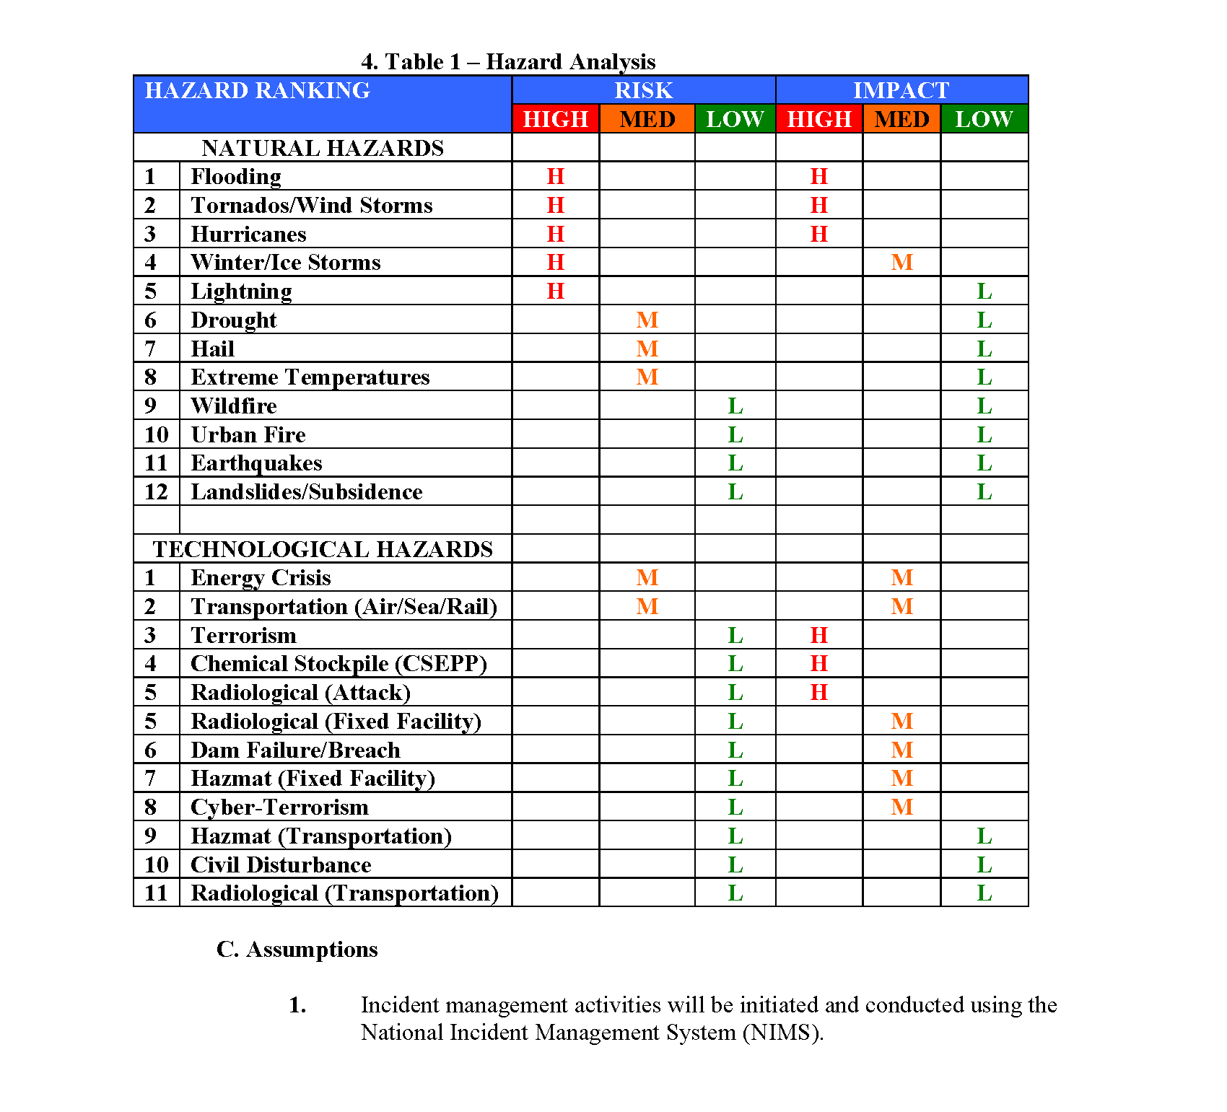
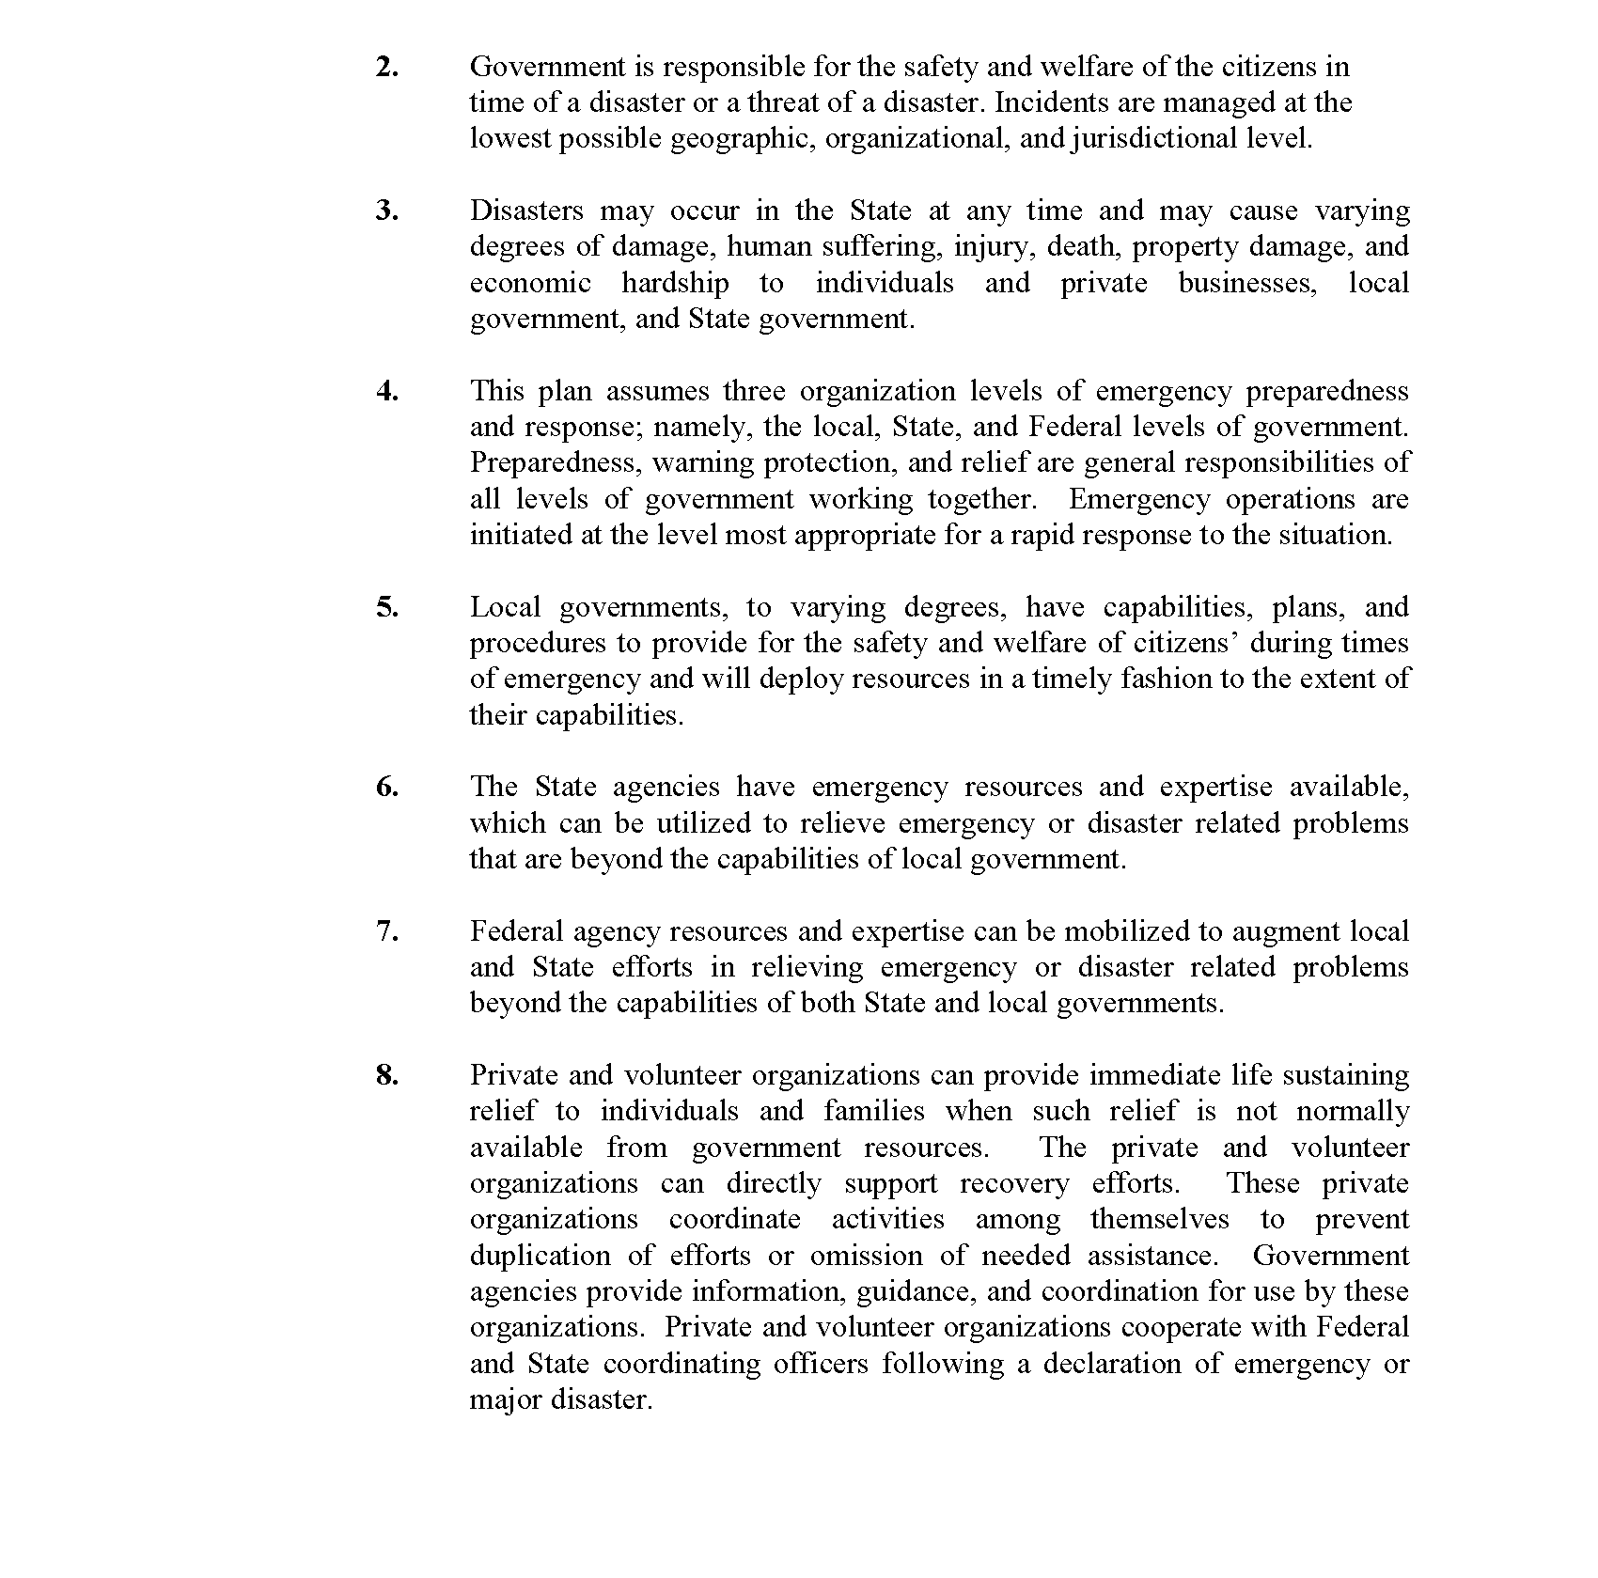

county hvaS

APPENDIX C: PANDEMIC INFLUENZA PLANNING ASSUMPTIONS

1.1. Planning Assumptions
1.1.1. Susceptibility to the pandemic influenza virus will be universal.
1.1.2. Efficient and sustained person-to-person transmission signals an imminent pandemic.
1.1.3. The clinical disease attack rate will likely be 30% or higher in the overall population during the pandemic. Illness rates will be highest among school-aged children (about 40%) and decline with age. Among working adults, an average of 20% will become ill during a community outbreak.
1.1.3.1. Some persons will become infected but not develop clinically significant symptoms. Asymptomatic or minimally symptomatic individuals can transmit infection and develop immunity to subsequent infection.
1.1.4. Of those who become ill with influenza, 50% will seek outpatient medical care.
1.1.4.1. With the availability of effective antiviral drugs for treatment, this proportion may be higher in the next pandemic.
1.1.5. The number of hospitalizations and deaths will depend on the virulence of the pandemic virus. Estimates differ about 10-fold between more and less severe scenarios. Two scenarios are presented based on extrapolation of past pandemic experience (Table 1). Planning should include the more severe scenario.
1.1.5.1. Risk groups for severe and fatal infection cannot be predicted with certainty but are likely to include infants, the elderly, pregnant women, and persons with chronic medical conditions.
1.1.6. Rates of absenteeism will depend on the severity of the pandemic.
1.1.6.1. In a severe pandemic, absenteeism attributable to illness, the need to care for ill family members and fear of infection may reach 40% during the peak weeks of a community outbreak, with lower rates of absenteeism during the weeks before and after the peak.
1.1.6.2. Certain public health measures (closing schools, quarantining household contacts of infected individuals, “snow days”) are likely to increase rates of absenteeism.
1.1.7. The typical incubation period (interval between infection and onset of symptoms) for influenza is approximately 2 days.
1.1.8. Persons who become ill may shed virus and can transmit infection for up to one day before the onset of illness. Viral shedding and the risk of transmission will be greatest during the first 2 days of illness. Children usually shed the greatest amount of virus and therefore are likely to post the greatest risk for transmission.
1.1.9. On average, infected persons will transmit infection to approximately two other people.
1.1.10. In an affected community, a pandemic outbreak will last about 6 to 8 weeks.
1.1.11. Multiple waves (periods during which community outbreaks occur across the country) of illness could occur with each wave lasting 2-3 months. Historically, the largest waves have occurred in the fall and winter, but the seasonality of a pandemic cannot be predicted with certainty.
Table 1. Number of Episodes of Illness, Healthcare Utilization, and Death Associated with Moderate and Severe Pandemic Influenza Scenarios*
Characteristic | Moderate (1958/68-like) | Severe (1918-like)
Illness | 90 million (30%) | 90 million (30%)
Outpatient medical care | 45 million (50%) | 45 million (50%)
Hospitalization | 865,000 | 9,900,000
ICU care | 128,750 | 1,485,000
Mechanical ventilation | 64,875 | 745,500
Deaths | 209,000 | 1,903,000
*Estimates based on extrapolation from past pandemics in the United States. Note that these estimates do not include the potential impact of interventions not available during the 20th century pandemics.

APPENDIX D: PANDEMIC INFLUENZA telework plan

APPENDIX E: DOCUMENTATION OF COMPLIANCE WITH APPENDIX A OF THE CDC STATE PANFLU OPERATIONS PLAN

 | Appendix A.1: Sustain Operations of State Agencies & Support and Protect Government Workers
 | Prepare
A.1.1.1 | Assess potential employee absences/ determine potential impact of a pandemic on the agencies’ workforce
A.1.1.2 | Determine essential functions and which employees have unique credentials
A.1.1.3 | Cross-train to provide 3-deep back-ups for the employees performing essential functions or who have unique credentials
A.1.1.4 | Establish standard operating procedures for essential functions
A.1.1.5 | Create telework plans
A.1.1.6 | Assess changes in demands on State agencies’ services
A.1.1.7 | Identify specific hiring needs and determine needed hiring flexibilities
A.1.1.8 | If needed, train and/or prepare ancillary workforce or create alternative plans for staffing of essential functions
A.1.1.9 | Consult with procurement staff and major contractors re HR issues
A.1.1.10 | Review relationships with suppliers/ shippers/other businesses that support States’ essential functions; as necessary, implement backup plans
 | Respond and Recover
A.1.1.11 | Implement telework and other HR flexible work schedules as per plan
A.1.1.12 | Employ pre-identified plans to maintain sufficient staffing (FTE and contractor) for essential functions and high-demand services
A.1.1.13 | Collect data and report the status of employees for the purpose of monitoring agency workforce levels and reporting such information to appropriate agencies (This includes a plan for accountability of personnel and their status and a plan to monitor who is sick, those that have recovered, those that are available for re-entry to work)
A.1.1.14 | Use pre-identified hiring/contracting flexibilities to replace employees/ contractors unable to work (or return to work)
A.1.1.15 | Implement previously developed employee-labor relations plan
A.1.1.16 | Monitor effectiveness and consistency of application of HR flexibilities by agencies
 | Sub-objective A.1.2 - Assist employees of State agencies unable to work for a significant time period
 | Prepare
A.1.2.1 | Assess flexible work schedules (can include cross reference to telework plans from A.1.1.e.) (States should assess current policies and then report on decisions)
A.1.2.2 | Review and revise, as necessary, policies and/or guidance on leave and benefits (States should assess current policies and then report on decisions)
A.1.2.3 | Ensure managers/supervisors are familiar with various leave options
A.1.2.4 | Consult with procurement staff/major contractors regarding pandemic plans for the contract workforce
 | Respond and Recover
A.1.2.5 | Implement telework and other flexible work schedules as per plan. Refer to the first Respond and Recover requirement under Sub-Objective A.1.1 - Ensure continuity of government in face of significantly increased absenteeism
A.1.2.6 | Implement any special pandemic compensation/ leave/benefit policies
 | Sub-objective A.1.3 - Communicate with employees of State agencies
 | Prepare
A.1.3.1 | Develop a communications plan
A.1.3.2 | Convey to all employees the State’s pandemic plan
A.1.3.3 | Provide reliable pandemic influenza information to employees
 | Respond and Recover
A.1.3.4 | Update information for employees on State’s operating status and latest pandemic influenza information; continue to advise employees concerning HR policies, workplace flexibilities, pay and benefits, etc.
 | Sub-objective A.1.4 - Consult with bargaining units (if the State has bargaining unit employees)
 | Prepare
A.1.4.1 | Consult with bargaining units (if the State has bargaining unit employees)
 | Respond and Recover
A.1.4.2 | Implement previously developed employee-labor relations plan
 | Sub-objective A.1.5 - Make State agency workplaces safe places
 | Prepare
A.1.5.1 | Establish policies and practices for preventing influenza spread at the worksite; implement those that can be done in advance of a pandemic (e.g., providing infection control supplies)
A.1.5.2 | Complete a risk assessment for all jobs (see OSHA guidance at www.osha.gov/Publications/ influenza_pandemic.html)
A.1.5.3 | Develop plans to protect those employees in the very high, high, or medium risk categories including stockpiling PPE (if PPE is needed); provided needed training and if respiratory protection is indicated, establish a respiratory protection program and fit-test those employees who will be provided with respirators.
 | Respond and Recover
A.1.5.4 | Implement infection control policies and practices (see OSHA guidance at www.osha.gov/Publications/ influenza_pandemic.html)
A.1.5.5 | Institute protection plans; if in plan, provide PPE to employees in very high, high, or medium risk categories
A.1.5.6 | If part of pandemic plan, distribute antiviral drugs
 | Sub-objective A.1.6 - Revise human resource and other workplace policies affecting the safety of State government workers
 | Prepare
A.1.6.1 | Review and revise policies on leave, as needed; consider new policies for employee compensation and sick-leave absences unique to a pandemic to encourage ill employees or those exposed to ill persons to stay home (States should assess current policies and then report on decisions)
A.1.6.2 | Establish guidelines on when a previously ill person is no longer infectious and can return to work
A.1.6.3 | Consider establishing policies for restricting travel (States should assess current policies and then report on decision)
A.1.6.4 | Collaborate with insurers, health plans, and local healthcare facilities on pandemic planning; evaluate government employee access to and availability of healthcare services
A.1.6.5 | Evaluate government employee access to and availability of mental health and social services; develop workforce resilience programs
 | Respond and Recover
A.1.6.6 | Implement policies/guidance developed to assist employees to stay home when exposed to the influenza or if ill
A.1.6.7 | Implement return to work guidelines
A.1.6.8 | Implement any travel policies; issue instructions for employees in high-risk situations
A.1.6.9 | Activate programs to address the psychological and social needs of government employees

APPENDIX F: INCIDENT COMMAND SYSTEM

Incident Commander— responsible for all aspects of the response, including developing incident objectives and managing all incident operations. Unless specifically assigned to another member of the Command or General Staffs, these responsibilities remain with the IC. Some of the more complex responsibilities of the IC include:
- Establish immediate priorities especially the safety of responders, other emergency workers, bystanders, and people involved in the incident.
- Stabilize the incident by ensuring life safety and managing resources efficiently and cost effectively.
- Determine incident objectives and strategy to achieve the objectives.
- Establish and monitor incident organization.
- Approve the implementation of the written or oral Incident Action Plan.
- Ensure adequate health and safety measures are in place.

The Command Staff—responsible for public affairs, health and safety, and liaison activities within the incident command structure. The IC remains responsible for these activities or may assign individuals to carry out these responsibilities and report directly to the IC
Information Officer—is responsible for developing and releasing information about the incident to the news media, incident personnel, and other appropriate agencies and organizations.
Liaison Officer—serves as the point of contact for assisting and coordinating activities between the IC and various agencies and groups. This may include federal personnel, state government officials, local government officials, and criminal investigating organizations and investigators arriving on the scene.
The Safety Officer—develops and recommends measures to the IC for assuring personnel health and safety and to assess and/or anticipate hazardous and unsafe situations. The Safety Officer also develops the Site Safety Plan, reviews the Incident Action Plan for safety implications, and provides timely, complete, specific, and accurate assessment of hazards and required controls.

The General Staff— includes Operations, Planning, Logistics, and Finance/Administrative responsibilities. These responsibilities remain with the IC until they are assigned to another individual. When the Operations, Planning, Logistics or Finance/Administrative responsibilities are established as separate functions under the IC, they are managed by a section chief and can be supported by other functional units.
Operations Chief— responsible for all operations directly applicable to the primary mission of the response.
Planning Chief— responsible for collecting, evaluating, and disseminating the tactical information related to the incident, and for preparing and documenting Incident Action Plans (IAP's).
Logistics Chief— responsible for providing facilities, services, and materials for the incident response.
Finance and Administrative Chief is responsible for all financial, administrative, and cost analysis aspects of the incident.

The modular organization of the ICS allows responders to scale their efforts and apply the parts of the ICS structure that best meet the demands of the incident. In other words, there are no hard and fast rules for when or how to expand the ICS organization. Many incidents will never require the activation of Planning, Logistics, or Finance/Administration Sections, while others will require some or all of them to be established. A major advantage of the ICS organization is the ability to fill only those parts of the organization required. For some incidents, and in some applications, only a few of the organization’s functional elements may be required. However, if there is a need to expand the organization, additional positions exist within the ICS framework to meet virtually any need.

For example, in responses involving responders from a single jurisdiction, the ICS establishes an organization for comprehensive response management. However, when an incident involves more than one agency or jurisdiction, responders can expand the ICS framework to address a multi-jurisdictional incident.

The roles of the ICS participants will also vary depending on the incident and may even vary during the same incident. Staffing considerations are based on the needs of the incident. The number of personnel and the organization structure are dependent on the size and complexity of the incident. There is no absolute standard to follow. However, large-scale incidents will usually require that each component, or section, is set up separately with different staff members managing each section. A basic operating guideline is that the Incident Commander is responsible for all activities until command authority is transferred to another person.

APPENDIX G: TOOL FOR MONITORING EMPLOYEE AVAILABILTY AND ABSENCES

Name | Organizational Position | Original Status Code | Date of Original Status | Change in Status Code | Date of Status Change | Date Restored to Original Status
Status Codes:
- Present at primary location
- Present at Alternate Location
- Absent—illness
- Absent—caring for ill family member
- Deceased

APPENDIX h: ACRONYMS

AAR After-Action Report
ADPH Alabama Department of Public Health
AEMA Alabama Emergency Management Agency
CET Continuity Evaluation Tool
CI/KR Critical Infrastructure/Key Resources
COG Continuity of Government
COGCON Continuity of Government Readiness Conditions
COOP Continuity of Operations
CWG Continuity Working Group
DHS Department of Homeland Security
ECG Enduring Constitutional Government
ERG Emergency Relocation Group
ESF Emergency Support Function
FCD Federal Continuity Directive
FEA Federal Executive Association
FEB Federal Executive Board
FEMA Federal Emergency Management Agency
HQ Headquarters
HSAS Homeland Security Advisory System
HSEEP Homeland Security Exercise and Evaluation Program
HSPD Homeland Security Presidential Directive
HVA Hazard Vulnerability Analysis
IP Improvement Plan
IT Information Technology
MEF Mission Essential Function
MOA/MOU Memorandum of Agreement/Memorandum of Understanding
MYSPMP Multi-Year Strategy and Program Management Plan
NCC National Continuity Coordinator
NCP National Continuity Programs
NCR National Capital Region
NCS National Communications System
NEF National Essential Function
NEP National Exercise Program
NIMS National Incident Management System
NIPP National Infrastructure Protection Plan
NRF National Response Framework
NSPD National Security Presidential Directive
OEP Occupant Emergency Plan
OMB Office of Management and Budget
OPM Office of Personnel Management
OSTP Office of Science and Technology Policy
PMEF Primary Mission Essential Function
POC Point of Contact
SIP Shelter-In-Place
TT&E Test, Training, and Exercise
WMD Weapons of Mass Destruction

http://www.southcentralpartnership.org
Source: http://www.pandemicflu.gov/plan/pandplan.html

